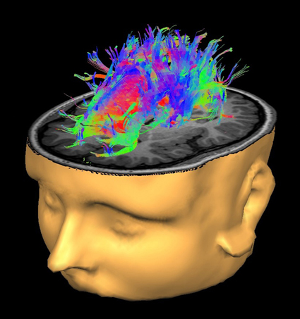

Now recruiting!
We are now recruiting children with ADHD and healthy control participants for a study that will help us learn more about new methods for diagnosing and treating ADHD.

What is the purpose of the study? The purpose of this study is to test a new way of performing MRI scans more rapidly and to learn more about brain differences among children and adolescents with and without ADHD.

Who can participate? Children with ADHD, ages 7 to 12, who are taking or have taken medication for ADHD; OR, typically developing children, ages 7 to 11, who do not have ADHD and who have never taken medication for ADHD.

What do I have to do if my child is in the study? There are two parts to this research study. In Part 1, potential participants will be screened (over the phone) for any conditions which would make them ineligible to complete an MRI and to rule out other developmental or health problems that would disqualify them from participating.

In Part 2, participants who qualify are invited to Boston Children’s Hospital Waltham for 1) a brief set of neurocognitive tests; 2) parent interview; and 3) a brief MRI scan.

What is the time commitment for the study? Part 1 total time: approximately 30 minutes. Part 2 total time: up to 3 hours (neurocognitive tests: approximately 2 hours; MRI scan: 1-hour appointment, but roughly 20-minute MRI scan time).

What are the benefits of the study? You will be provided a personalized report of findings pertaining to your child. Additionally, the MRI techniques being developed as part of this study will greatly benefit the study of ADHD and other neurological conditions. Identifying MRI features that correlate with ADHD symptoms could be potentially useful in the development of diagnosis and treatment strategies.

What will I receive from participating? A report summarizing the results of the cognitive assessments will be provided to all families. You will receive $10 for participating in Part 1 and, if your child qualifies, $100 for participating in Part 2.

Where will the study be conducted? Part 1 will be conducted by telephone. Part 2 will be conducted at the Waltham campus of Boston Children’s Hospital.

What do I do if I want to participate? You may contact our research coordinator at 617.355.8525 or
ADHDMRIstudy@childrens.harvard.edu

This research is being conducted by:
Departments of Psychiatry, Boston Children’s Hospital and Brigham and Women’s Hospital

Yogesh Rathi, PhD, Principal Investigator

Gloria McAnulty, PhD, Site Principal Investigator



This study is funded by the National Institute of Mental Health and approved by the Institutional Review Board of Boston Children’s Hospital.

